CPC600 Automated Calibration
16 August 2019

The calibration and adjustment of a mensor CPC600 module is automated by using these two macros:
- “mensorCalSled_Master”
- “mensorCalSled_AbsGauge”

The CPC600 has a primary range and secondary range, and automated adjustment for both ranges is supported. The DUT definition contains the setup information and initialization commands required to change between the two ranges.

The Test macro, “mensorCalSled_Master”, is called as the Test Event Macro in the Test Definition.
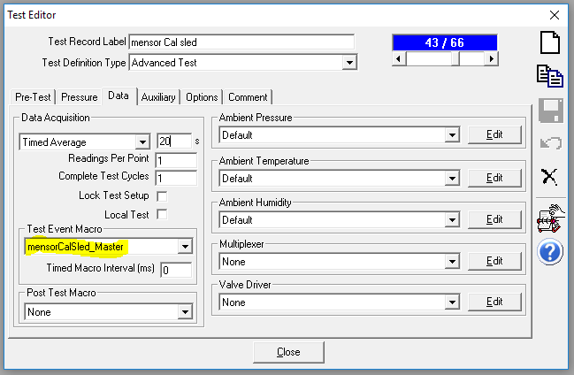

Two Pressure Cycles are required – the first cycle collects As Found data, and if required the second cycle collects the As Left verification data. At the end of the first pressure cycle the As Found data is analyzed for being in or out of tolerance. A “Tolerance Factor” is used to determine if the data is well inside of the specification or marginally inside. If it’s marginally inside then an adjustment is applied.
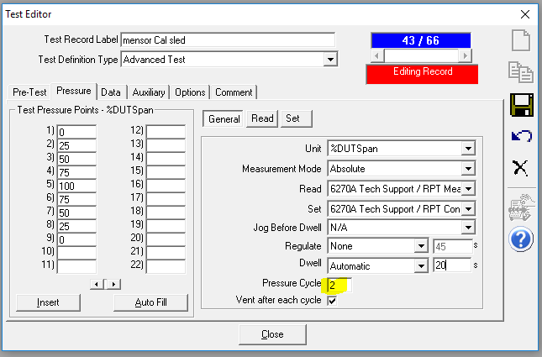

The DUT Definition is configured as an Advanced Device as there will be two outputs – one for the Primary and Secondary ranges. The Cal Sled communications are fixed at a baud rate of 57600 with <CR> only as the Command and Response terminator. A regular straight through RS232 cable is required.
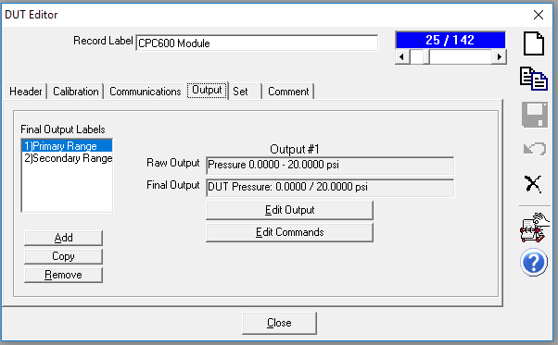
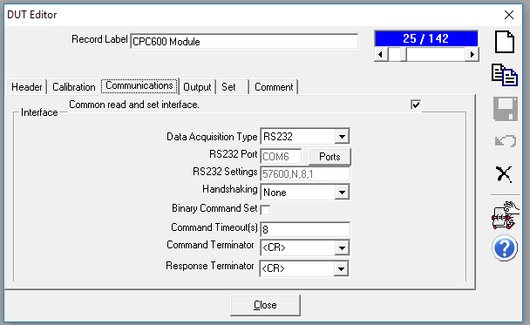

The remote commands configuration is nearly identical for both the Primary and Secondary ranges with the key difference being the range change command:
- #1SW 1 = Primary Range
- #1SW 2 = Secondary Range
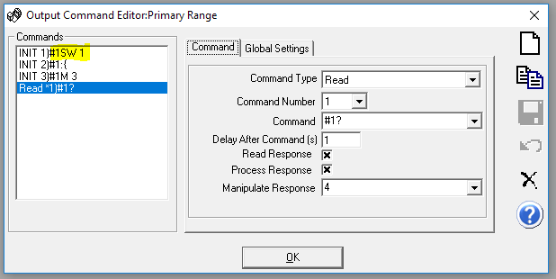
Note: the Read command requires a “Manipulate Response” value of “4” to strip away the first four leading characters.

mensorCalSled_Master code:

'This is the main TestEvent Macro to use with a mensor CPC600 module calibration.
'It's used to call "mensorCalSled_AbsGauge" test macro. As of August 2019
'only gauge mode and absolute mode modules are supported. It's likely that
'differential mode would be but this has not been tested.
'*********************************************************************

Function mensorCalSledCalibrationAdjust(iT, iL, iC, iP, cTest, cConfig)

' Determine which macro to run.

Select Case cTest.TestPrsMeasMode
Case 0:
Call mensorCalSledGauge(iT, iL, iC, iP, cTest, cConfig)
Case 1:
Call mensorCalSledGauge(iT, iL, iC, iP, cTest, cConfig)
Case 3:
Call mensorCalSledDifferential(iT, iL, iC, iP, cTest, cConfig)

End Select

End Function

Function mensorCalSled_Dwell(dwell) '"dwell" declared as a parameter of the function.
cDebug.LogStatus "Dwell for " & dwell & "s"
tStart = timer
Do
cCOMPASS.TimeDelay 1
td = CInt(dwell-time_Difference(tStart))
cCOMPASS.StatusDisplay "Dwell..." & td
If cCOMPASS.SystemAbort Then Exit Function
If td <= 0 Then Exit Do
Loop Until False
End Function

Function mensorCalSled_WaitForReady(isZero, timeout)
cDebug.LogStatus "Wait for Ready: timeout=" & timeout
tStart = Timer

'The Do Loop tells COMPASS to look at the logic output of the UseReady method. The logic True / False
'can be queried by using the .Ready parameter. The return from cConfig.SetPres(1).Ready is either TRUE or FALSE.

Do
cCOMPASS.TimeDelay 2 'delay controller
cCOMPASS.StatusDisplay process & ": Waiting for Ready.........."
If cCOMPASS.SystemAbort Then Exit Function

If time_Difference(tStart) > timeout Then
cDebug.LogStatus "*******TIMEOUT WAITING for Ready****"
cCOMPASS.StatusDisplay process & ": ............TIMEOUT Waiting for Ready.........."
cCOMPASS.TimeDelay 5 'delay to show above message
If (cCOMPASS.cConfig.DUTPrs(1).RangeMain.MeasMode = 0) And (isZero = 1) Then
cDebug.LogStatus "Timeout for absolute 0, as good as it will get"
Exit Do 'absolute 0, as good as possible
End If
Exit Function
End If

'If the SetPrs device supports the UseReady concept then loop until the .Ready parameter becomes TRUE or,
'If the SetPrs device doesn't support UseReady then look at if the RefPrs device does. The presumption
'is that either the controller or the reference device will support the UseReady method. Exit the loop
'once one of these two devices indicates Ready.

If cConfig.SetPrs(1).RangeMain.Useready Then
cDebug.LogStatus "Wait for ready...SetPrs.Ready=" & cConfig.SetPrs(1).Ready
If cConfig.SetPrs(1).Ready Then Exit Do
Else
cDebug.LogStatus "Wait for ready...RefPrs.Ready=" & cConfig.RefPrs(1).Ready
If cConfig.RefPrs(1).Ready Then Exit Do
End If
Loop
mensorCalSled_WaitForReady = True

End Function

Function mensorCalSled_Date()
yy = right(Year(Date),2)
dd = Right(String(2, "0") & Day(Date), 2)
mm = Right(String(2, "0") & Month(Date), 2)
mensorCalSled_Date = mm & dd & yy
End Function

mensorCalSled_AbsGauge code:

'******************************************************************************
'Used to calibrate and adjust gauge and absolute mode CPR6000 modules using the mensor
'cal sled. Called by the master test macro "mensorCalSled_Master".
'
'This version includes logic to test the As Found data for being inside of 70%
'of Tolerance. If it is then the test ends; if not then adjustments are made
'and the test runs a second cycle.
'
'This version include range querying information. This macro works for both
'Range 1 and Range 2.
'
'The Test Definition must be configured for two pressure cycles, and the macro
'is called as a Test Event macro.

'16 Aug 2019: edited to include the Exp numberic conversion.
'******************************************************************************

Function mensorCalSledGauge(iT, iL, iC, iP, cTest, cConfig)
Dim SC_Removed_Data()
Dim Reference_Data()
Dim SC_Corrected_Data()
Dim res(4,7)

ZC = 0
SC = 0

'<currentteststep 1010 - record AF coefs.>
If cCOMPASS.CurrentTestStep = 1010 Then ' Test Definition data files were created for each DUT.
cDebug.LogStatus "Capture As Found Coeffs"

For i = 1 To cConfig.DUTPrs.Count
cDebug.LogStatus "DUT: " & i
' Read module range info
Rnge = cConfig.DUTPrs(CInt(i)).IoSendCommand("#1B?", False)
RngeP = cConfig.DUTPrs(CInt(i)).IoSendCommand("#1R+?", False)
cDebug.LogStatus "Module Range being calibrated: " & Rnge
cDebug.LogStatus "Module Range FS (psi): " & RngeP

' Read A/F ZC from module; write to calcoef1:
ZCraw = cConfig.DUTPrs(CInt(i)).IoSendCommand("#1ZC?", False)
ZC = Mid(ZCraw,6,10)
cCOMPASS.DataCollection(i).DUT.CalibrationCoefficient1 = ZC
cDebug.LogStatus "Command #1ZC?: " & ZC
cDebug.LogStatus "ZC Coefficient: " & cCOMPASS.DataCollection(i).DUT.CalibrationCoefficient1

' Read A/F SC from module; write to calcoef2
SCraw = cConfig.DUTPrs(CInt(i)).IoSendCommand("#1SC?", False)
SC = Mid(SCraw,6,10)
cCOMPASS.DataCollection(i).DUT.CalibrationCoefficient2 = SC
cDebug.LogStatus "Command #1SC?: " & SC
cDebug.LogStatus "SC Coefficient: " & cCOMPASS.DataCollection(i).DUT.CalibrationCoefficient2

' There is no Zoffset used with the CPR6000
zOffset = 0

calDate = cConfig.DUTPrs(CInt(i)).IoSendCommand("#1DC?", False)
cCOMPASS.DataCollection(i).DUT.LastCalDate = calDate
cDebug.LogStatus "Command #1DC?: " & calDate
cDebug.LogStatus "LastCalDate: " & cCOMPASS.DataCollection(i).DUT.LastCalDate

Next
cdebug.LogStatus "End of CurrentTestStep 1010"

ElseIf cCOMPASS.CurrentTestStep = 1150 And iC = 1 Then
cCOMPASS.StatusDisplay "Calculating Adjustment..."
cCOMPASS.TimeDelay 3
cDebug.LogStatus "First Cycle is complete. Starting CurrentTestStep 1150 - Evaluating data"
cDebug.LogStatus "#Data files: " & cCOMPASS.DataCollection.Count

'Evaluate A/F data for comparison to 70% of DUT Tolerance:
'70% DATA EVALUATION STAGE Evaluates if A/F data is within 70% of DUT Tolerance. If it is, then end the test.
TOLFACT = .70 '70% DUT Tolerance. User definable.

For i = 1 To cCOMPASS.DataCollection(1).NumberofPressurePoints
For j = 1 To cConfig.DUTPrs.Count
Ref = cCOMPASS.DataCollection(j).DataPointRef(1,1,1,CInt(i)).RefPressure
DUT = cCOMPASS.DataCollection(j).DataPointRef(1,1,1,CInt(i)).DUTPressure
Tol = cCOMPASS.DataCollection(j).DataPointRef(1,1,1,CInt(i)).Tolerance
ST = cCOMPASS.DataCollection(j).DataPointRef(1,1,1,CInt(i)).Status
cDebug.LogStatus "DUT Tolerance is: "& Tol

If abs(DUT-Ref) > Tol * TOLFACT Then
FAIL = True
cDebug.Logstatus "Test point error(s) were outside 70% of Tolerance."
cCOMPASS.Statusdisplay "Test point error(s) were greater than 70% of Tolerance. Preparing To apply adjustments and run an As Left verification."
cCOMPASS.TimeDelay 6
Exit For

Else
cDebug.Logstatus "Test point agreement is inside 70% of Tolerance. A/F data = A/L data. "
cCOMPASS.StatusDisplay "Test point agreement is inside of 70% of tolerance. No adjustments will be made. Preparing to finish calibration."
cCOMPASS.TimeDelay 6
End If
Next
If fail = True Then Exit For
cDebug.LogStatus "Ending test after 1 cycle. Disregard the next 1 second of MacStat entries - no edits to coefs were applied. "
cCOMPASS.AbortTest True
Next
'END OF 70% TOL CHECK.

'If outside of 70% Tolerance then begin the adjustment based on As Found data.
'Back out the A/F coefficients...
For i = 1 To cConfig.DUTPrs.Count
pressurePoints = cCOMPASS.DataCollection(i).NumberofPressurePoints
cDebug.LogStatus "DUT: " & i & " - Pressure Points: " & pressurePoints

Redim Reference_Data(pressurePoints-1)
Redim SC_Removed_Data(pressurePoints-1)
Redim SC_Corrected_Data(pressurePoints-1)

'populate module A/F coefficients from memory:
ZC = cCOMPASS.DataCollection(i).DUT.CalibrationCoefficient1
SC = cCOMPASS.DataCollection(i).DUT.CalibrationCoefficient2
zOffset = 0
cDebug.LogStatus "ZC: " & ZC
cDebug.LogStatus "SC: " & SC
dutUnit = cConfig.DUTPrs(i).RangeMain.UnitFinal
cDebug.LogStatus "DUT UnitFinal: " & dutUnit
cDebug.LogStatus "DUT UnitFinalText: " & cConfig.DUTPrs(i).RangeMain.UnitFinalText
refUnit = cConfig.RefPrs(i).RangeMain.UnitFinal
cDebug.LogStatus "Ref UnitFinal: " & refUnit
cDebug.LogStatus "Ref UnitFinal: " & cConfig.RefPrs(i).RangeMain.UnitFinalText

' Iterate through each pressure point
For j = 1 To pressurePoints
ix = CInt(j)-1
cDebug.LogStatus "mensorAdjust, DUTPressurePoint(" & j & ")"
DUTPressure = cCOMPASS.DataCollection(i).DataPointRef(1, 1, 1, CInt(j)).DUTPressure
cDebug.LogStatus "mensorAdjust, DUTPressure: " & DUTPressure

DUTPsiPres = cCOMPASS.UnitConversion(CDbl(DUTPressure), 9, CInt(dutUnit), 0)
cDebug.LogStatus "mensorAdjust, DUTPsiPres: " & DUTPsiPres
'this is our Pressure with A/F coefs applied. In y=mx+b it is our "y"

refPres = cCOMPASS.DataCollection(i).DataPointRef(1, 1, 1, CInt(j)).RefPressure
cDebug.LogStatus "mensorAdjust, RefPres: " & refPres
Reference_Data(ix) = cCOMPASS.UnitConversion(CDbl(refPres), 9, CInt(refUnit), 0)
cDebug.LogStatus "mensorAdjust, RefPsiPres: " & Reference_Data(ix)

'Determine raw zero and slope conditions. The goal is to determine the raw "x".
'NOTE: the CPC600 modules don't use a zoffset coefficient. Therefore this value is defined as 0 for the math.
zOff_Removed = CDbl(DUTPsiPres) - 0

ZC_Removed = zOff_Removed - ZC
'backs out the offset
'(y-b) = mx
cDebug.LogStatus "mensorAdjust, ZC_Removed: " & ZC_Removed

SC_Removed_Data(ix) = ZC_Removed / SC
'the result is our raw "x" pressure
'(y-b)/m = x
cDebug.LogStatus "mensorAdjust, SC_Removed_Data: " & SC_Removed_Data(ix)
Next

'Determine new A/L Zero and Slope...
'Poly-Fit is a COMPASS global code module for performing a linear regression on a data collection.
Call Poly_Fit(Reference_Data, SC_Removed_Data, res, 1)
slope = res(0,1)
cDebug.LogStatus "mensorAdjust, slope: " & slope
If slope = 0 Then
new_SC = 0
Else
new_SC = 1 / slope
End If
cDebug.LogStatus "calculated new_SC: " & new_SC

'Calculate the SC_corrected for each point:
For j = 0 To pressurePoints - 1
SC_Corrected_Data(CInt(j)) = SC_Removed_Data(CInt(j)) * new_SC
cDebug.LogStatus "mensorAdjust, SC_Corrected_DataPt(" & j & "): " & SC_Corrected_Data(CInt(j))
Next

Call Poly_Fit(Reference_Data, SC_Corrected_Data, res, 1)
new_ZC = 0 - res(0,0)
cDebug.LogStatus "variable new_ZC is: " & new_ZC
'Data type conversion:
dval = CDbl(new_ZC)
sval = FormatNumber(new_ZC,6)
sval = trim(sval) & "0000000000"
sval = left(sval,10)
new_ZC = sval
cmd = "#1ZC " & sval

'Save new coefs to memory AND write to the module but not yet saved to the module:
cCOMPASS.DataCollection(i).DUT.CalibrationCoefficient4 = new_ZC
cConfig.DUTPrs(CInt(i)).IoSendCommand "#1CALU",True
cCOMPASS.TimeDelay 1
Call cConfig.DUTPrs(CInt(i)).IoSendCommand(CStr(cmd), True)
cCOMPASS.TimeDelay 2
cDebug.LogStatus "CalibrationCoefficient4: " & cCOMPASS.DataCollection(i).DUT.CalibrationCoefficient4
cDebug.LogStatus "Sent command: " & cmd

cCOMPASS.DataCollection(i).DUT.CalibrationCoefficient5 = new_SC
'Data type conversion:
dval = CDbl(new_SC)
sval = FormatNumber(new_SC,6)
sval = trim(sval) & "0000000000"
sval = left(sval,10)
new_SC = sval
cmd = "#1SC " & sval

cConfig.DUTPrs(CInt(i)).IoSendCommand "#1CALU",True
cCOMPASS.TimeDelay 1
Call cConfig.DUTPrs(CInt(i)).IoSendCommand(CStr(cmd), True)
cCOMPASS.TimeDelay 2
cDebug.LogStatus "CalibrationCoefficient5: " & cCOMPASS.DataCollection(i).DUT.CalibrationCoefficient5
cDebug.LogStatus "Sent command: " & cmd

'Determine new date of calibration, save to memory AND write to module:
new_date = mensorCalSled_Date
cCOMPASS.DataCollection(i).DUT.CalDueDate = CDate(new_date)
cmd = "#1DC " & new_date
cConfig.DUTPrs(CInt(i)).IoSendCommand "#1CALU",True
Call cConfig.DUTPrs(CInt(i)).IoSendCommand(CStr(cmd), True)
cDebug.LogStatus "CalDueDate: " & cCOMPASS.DataCollection(i).DUT.CalDueDate
cDebug.LogStatus "Sent command: " & cmd

Next

Set obj = Nothing
cdebug.LogStatus "Finished with CurrentTestStep 1150"

'<currentteststep 2000 - test is complete, A/L data has been collected. Save the coefs>
' Test complete. The post test options have not displayed and the user notes have not been entered.
ElseIf cCOMPASS.CurrentTestStep = 2000 Then
cDebug.LogStatus "Test complete. CurrentTestStep 2000."

'OPTIONAL GUARD BANDING FEATURE: This block of code can be commented out if guardbanding evaluation is not desired.
TOLFACT = .50 '50% gaurdband. User definable.

For i = 1 To cCOMPASS.DataCollection(1).NumberofPressurePoints
For j = 1 To cConfig.DUTPrs.Count
Ref = cCOMPASS.DataCollection(j).DataPointRef(1,1,2,CInt(i)).RefPressure
DUT = cCOMPASS.DataCollection(j).DataPointRef(1,1,2,CInt(i)).DUTPressure
Tol = cCOMPASS.DataCollection(j).DataPointRef(1,1,2,CInt(i)).Tolerance
ST = cCOMPASS.DataCollection(j).DataPointRef(1,1,2,CInt(i)).Status

If abs(DUT-Ref) > Tol * TOLFACT Then
FAIL = True
cCOMPASS.DataCollection(j).DataPointRef(1,1,2,CInt(i)).Status = ST & "T"
'Generate Failure message for user
GB = msgbox("The As Left results did not fall inside the guardbanded tolerance. Click OK to continue.",0+48+4096, "Guard Band Warning")
Exit For
End If
Next
If fail = True Then Exit For
Next
'END OF GUARD BANDING CODE.

msg = "The test is complete. The coefficients are active in module memory but "
msg = msg & "have not been written to permanent memory. Would you like to activate "
msg = msg & "the calibration?"

If msgbox(msg,vbquestion + vbYesNo + vbSystemModal,"Activate Calibration") = vbNO Then
msg = "Cycling the power of the module will "
msg = msg & "remove the coefficients from the memory and reset the module."
msgbox msg,vbSystemModal,"Activate Calibration"
Exit Function
Else
For i = 1 To cConfig.DUTPrs.Count
cmd = "#1SAVE"
TimeDelay 2
Call cConfig.DUTPrs(CInt(i)).IoSendCommand(CStr(cmd), True)
cDebug.LogStatus "Sent command: " & cmd
cDebug.LogStatus "End of Adjustment macro operations."
Next
End If

End If

End Function

