**COMPASS Report Editor**

**Function SetPassFail**

**Check the status of each point and list PASS or FAIL and determine an overall test Pass/Fail value.**

**This is useful is you want to log default COMPASS Status (blank, T, R, r, t) in datafile**

**but also want to show Pass or Fail in report for Status**

First copy the text below on page 2 to a new DataFile macro and name it **SetPassFail**.

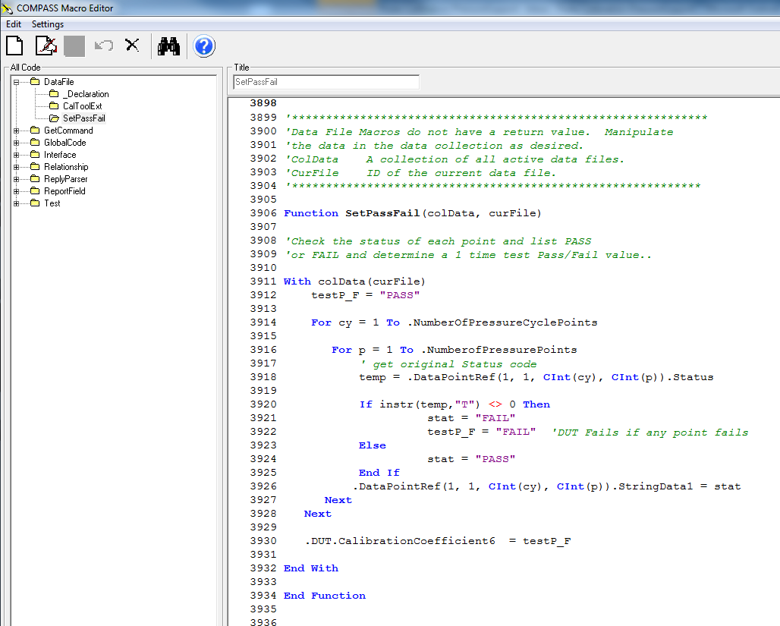

Macro changes status to PASS or FAIL

testP_F status is status of overall test. If one point fails, test fails.

SetPassFail is a DataFile macro

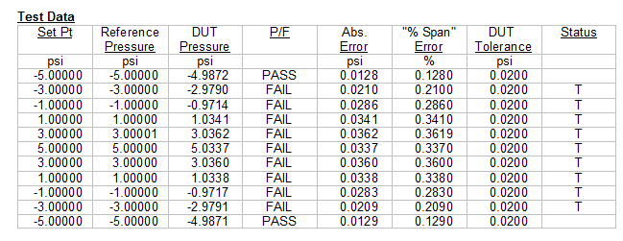

Default status, good to have in datafile for troubleshooting but confusing in report.

*'\*\*\*\*\*\*\*\*\*\*\*\*\*\*\*\*\*\*\*\*\*\*\*\*\*\*\*\*\*\*\*\*\*\*\*\*\*\*\*\*\*\*\*\*\*\*\*\*\*\*\*\*\*\*\*\*\*\*\*\*\**

*'Data File Macros do not have a return value. Manipulate*

*'the data in the data collection as desired.*

*'ColData A collection of all active data files.*

*'CurFile ID of the current data file.*

*'\*\*\*\*\*\*\*\*\*\*\*\*\*\*\*\*\*\*\*\*\*\*\*\*\*\*\*\*\*\*\*\*\*\*\*\*\*\*\*\*\*\*\*\*\*\*\*\*\*\*\*\*\*\*\*\*\*\*\*\**

**Function** SetPassFail(colData, curFile)

*'Check the status of each point and list PASS or FAIL*

*'and determine overall Pass/Fail value for each Pressure Cycle*

**With** colData(curFile)

*'Pressure Cycle Status set to PASS unless a point in the test failed*

testP_F = "PASS"

*'Determine overall pressure cycle Pass/Fail status*

**For** cy = 1 **To** .NumberOfPressureCyclePoints

*'Determine status of each point*

**For** p = 1 **To** .NumberofPressurePoints

*' get original Status code*

temp = .DataPointRef(1, 1, **CInt**(cy), **CInt**(p)).Status

**If** instr(temp,"T") <> 0 **Then**

stat = "FAIL"

testP_F = "FAIL" *'DUT Fails if any point fails*

**Else**

stat = "PASS"

**End If**

*'Set status of each point*

.DataPointRef(1, 1, **CInt**(cy), **CInt**(p)).StringData1 = stat

**Next**

**Next**

*'Set Pressure Cycle Status to DUT Cal Coef 6 and can show in Report*

.DUT.CalibrationCoefficient6 = testP_F

**End With**

**End Function**

Put Stringdata1 field into the COMPASS Report Editor Template and select SetPassFail as a Template Macro. Double-click on Template Macros to open the Template Macros window and then double-click the SetPassFail macro on the left “Available Macros” to move it to the right “Selected Template Macros”.

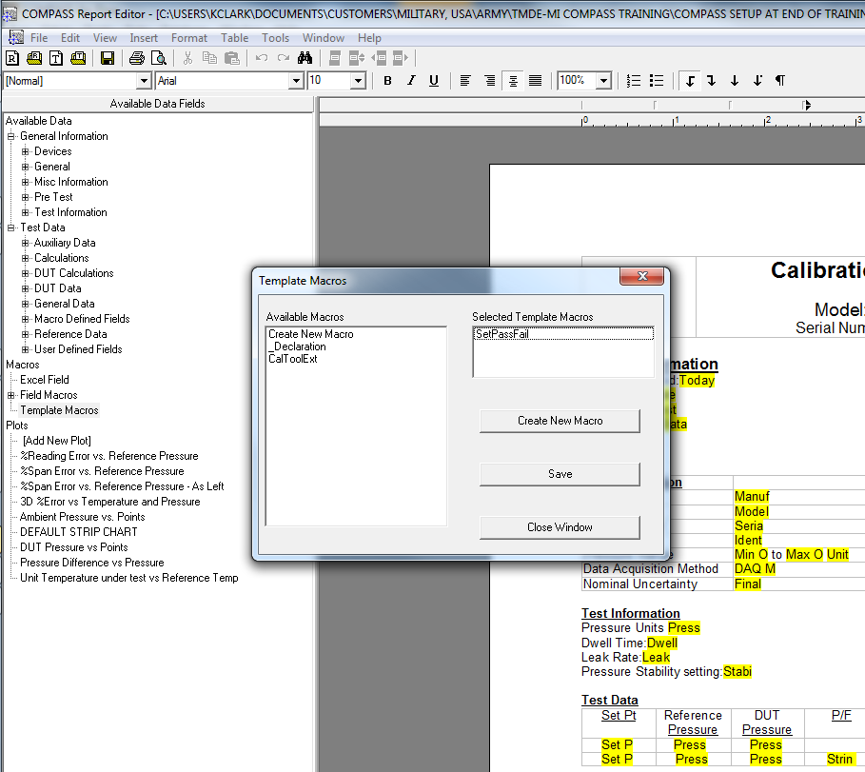

String Data 1 here

SetPassFail macro is selected

Add or edit the table in the template so String Data 1 is used for Status.

String Data 1 comes from “Available Data” -> “Test Data” -> “User Defined Fields” -> “String Data 1”

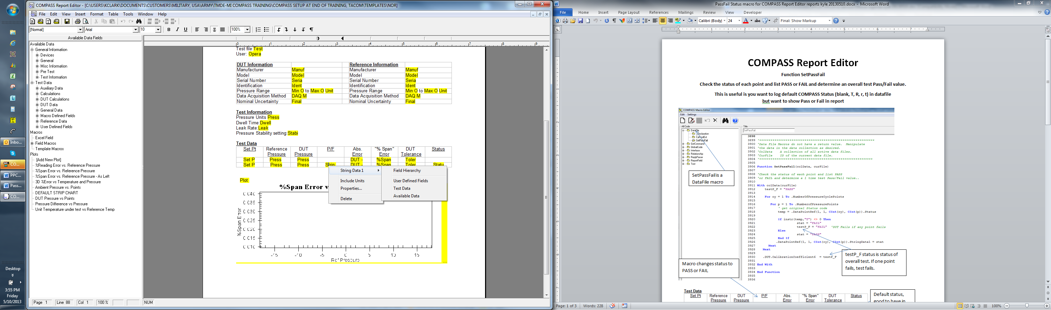

In the String Data 1 Properties window make sure Individual Data Point is set to 0 so Status is shown for all setpoints in the datafile.

Uncheck the box “Use PASS/FAIL for the status of each test point.” The macro will set PASS/FAIL for you now.

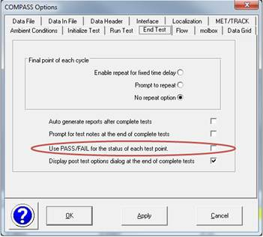

Note that if you want to use this macro on another computer you also have to transfer the macro and not just the template file. Use the [Database], <COMPASS Database Management Tool> to copy the macro to another database.

