Using Multiple Reference in a Test
Revised: 04 April 2017
M. Daniels

Requires the Test Definition Type to be “Advanced” so that multiple reference devices can be used. With this example, the 2465A-754 is called as the READ device and the SET device is manual.
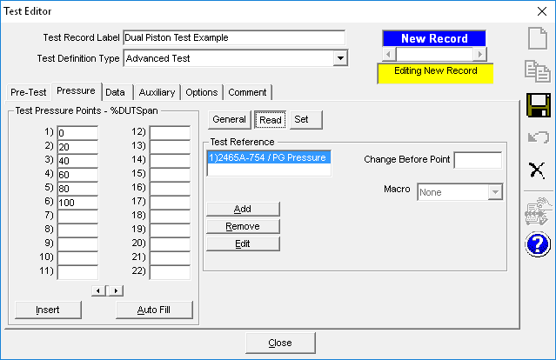
Clicking the “Add” button brings up this screen:
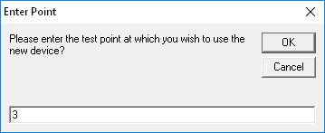

Select the 2465 platform:
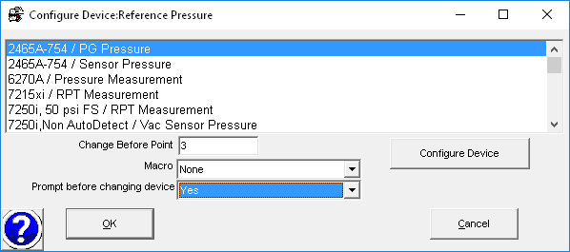

Click “Configure Device” to specify which piston-cylinder should be used at point 3:
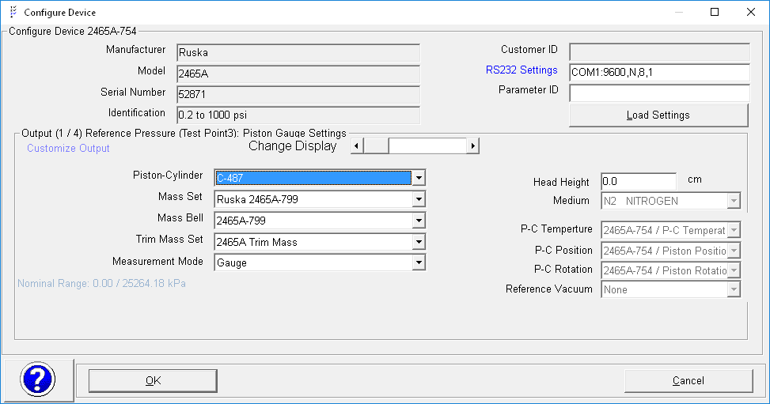
OK to close, then OK to close the previous window.

Once configured, then the “R” designator at point 3 to indicate a Reference Change to occur prior to testing at point 3.
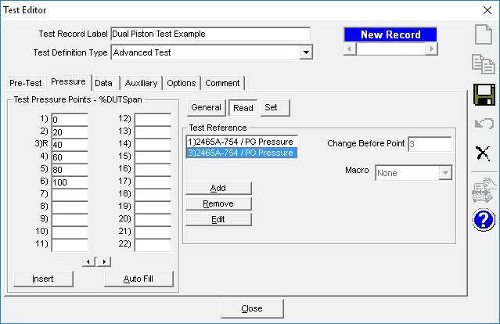

If the test points were to descend back down then the need would be to switch back to the low range piston. Because the original Reference Device (the low range piston-cylinder) will be used a second time, it simply needs to be edited to indicate that it will be used again at point #10.

Select the First Test Reference Device and click the Edit button.
Select the Reference Device and add to the “Change Before Point” field the semi-colon character and the test point for where the change should occur.
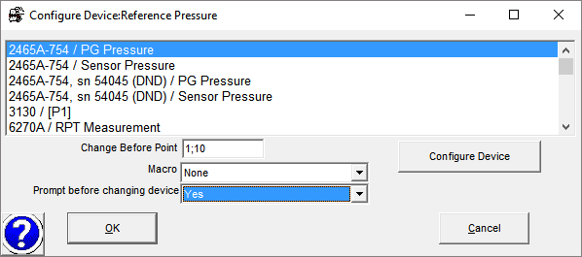
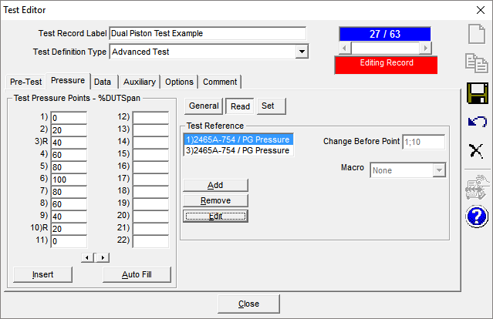

The same techniques apply to using multiple SET devices. Any reference and any type of pressure controller can be used and/or changed during a test.

