COMPASS for Pressure with CalTool Integration
01 May 2020
M. Daniels

The CalTool Extension provides fully automated end-to-end calibration and adjustment of DHI designed hardware. Historically, the data collection part of the calibration of RPTs and Q-RPTs was performed with COMPASS for Pressures software, and the adjustment part was performed with CalTools for RPT software. The functionality of the CalTool Extension is similar to the 700P, PMM Cal Sled, and 6270A In-Chassis calibration routines. However, the CalTool Extension is ActiveX based instead of macro based and requires the use of the CalToolExt.dll file.

This tutorial is a quick-read summary. For a more extensive look at this process, please review the Application Note “How to calibrate reference pressure transducers with COMPASS for Pressure Software”. The application notes provides an excellent three-page appendix which explains the calculations.

Files to Download:
COMPASS v5.0 does not include the CalToolExt.dll file as part of the standard installation and it must be manually installed and registered.

These files are available for download as part of this tutorial.
- Download and install the files in the “Program Files (x86)\Common Files\DH Instruments” directory. Administrator rights will be required.
- “CalToolExt.dll”
- “regfiles_new.bat”
- Right-Click on the “regfiles_new.bat” and select Run as Administrator. This will register the dll file.

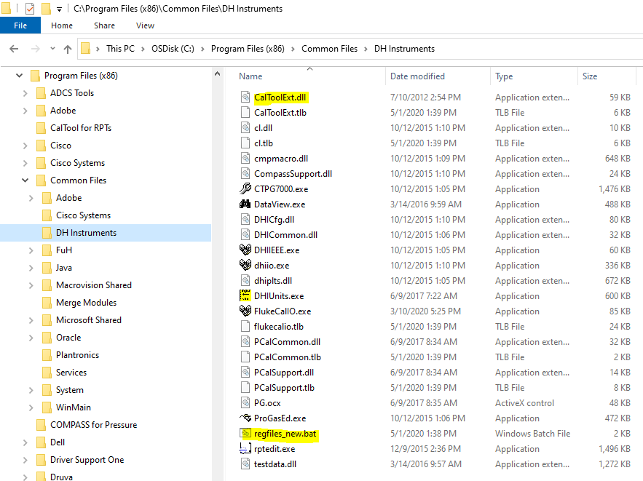
COMPASS Configuration selections
Certain options need to be enabled within the COMPASS program to support the logging of calibration coefficients and reporting to the .dat file. From the [Tools],<Options> menu enable “Load calibration info for auto-detect devices”.
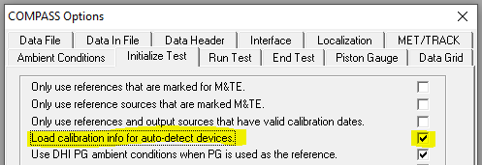

Three additional data fields must be included with the data files. These fields are not part of the default collection and must be moved over from the “Available Fields” to the “Fields to log” column.
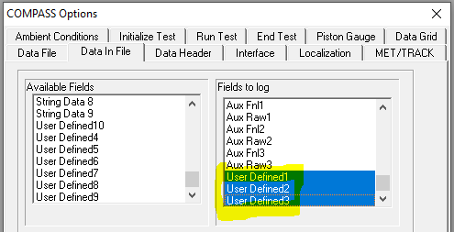

A new menu option is provided as a convenience option to get a snap shot of the calibration coefficients. [Data] “View Calibration Coefficients”:
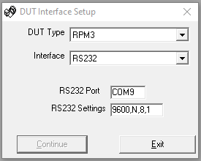

Test Definition
The Test Definition requires the use of a PreTest and a Test Event Macro.
- CalActivate_PreTest – PreTest Macro. Prompts the user to select Force Standard Regression for gauge mode calibrations, and prompts user if he wants to apply adjustments to the H2 and H1 (L2 and L1) subranges.
- CalActivate – Test Event Macro. Writes the new coefficients at the end of cycle 1 and then runs cycle 2 for A/L verification.

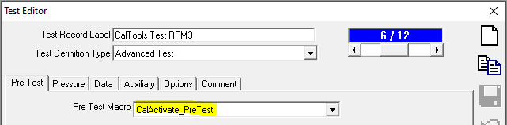

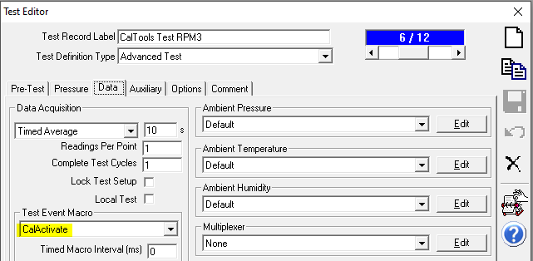

Two pressure cycles are required to complete the As Found and As Left data sets:
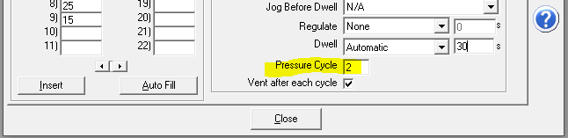

Templates and Template Macros
A pair of report templates are provided to process and present the data collected during the test:
- “CalTool Extension_AF w AL.tpl” (RPTCalibration_As Left.tpl) – this template reports both the As Found and As Left calibrations into a single report. It includes both sets of coefficients and test data results.
- “CalTool Extension_single cycle.tpl” (RPTCalibration.tpl)

The templates use a Field Macro called “CalInfo” (as in Calibration Information) to populate the A/F and A/L coefficients and calibration date:
- The numbered Dynamic Data Links are key to allowing the data to populate. This part of the template must remain as-is for the fields to populate. The macro pulls the data from the CalInfo2, 3 and 5 fields from the .dat file.
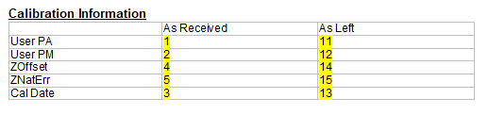
To support the method of running a single calibration cycle and then deciding if the adjustment should be made, an optional template macro must be enabled in the COMPASS Report Editor tool.

A Template Macro named “CalToolExt” which is also known as a DataFile macro, is used to call the CalToolExt.dll to manipulate the .dat file.
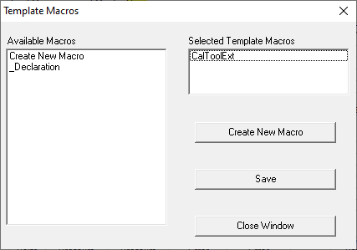
- The template macro is required only if the user wants to review the test results at the end of the first pressure cycle and make a decision to activate the changes. If this option is used then a second calibration test run is required to attain As Left verification data.
- This method replicates how the Phoenix lab handles RPT calibration – As Found data only with a predicted As Left.
- If the user wants a fully automated end-to-end calibration then this template macro is not required. This is the more common approach. The Test Definition must have the number of pressure cycles set to “2”.

