Additel 681
11 July 2018

- Requires a non-traditional termination character – a decimal “0”
- Must use a GetCommand macro to append Chr(0) to end of the command string(s).

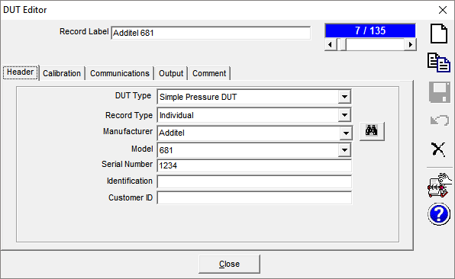

The Command and Response Terminator fields should be empty (delete):
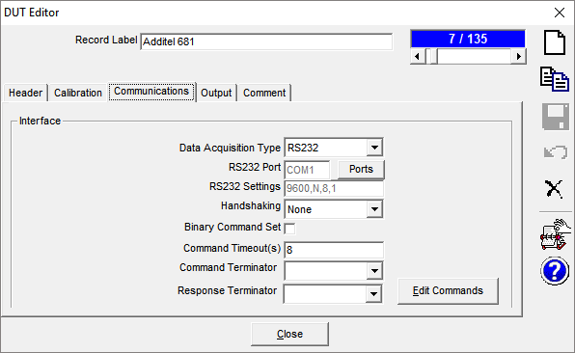

Edit Commands:
- Must use a “GetCommand” macro for the command string.
- Manipulate Response by telling COMPASS to strip away the first three blocks of non-numerical data which gets returned in the string.
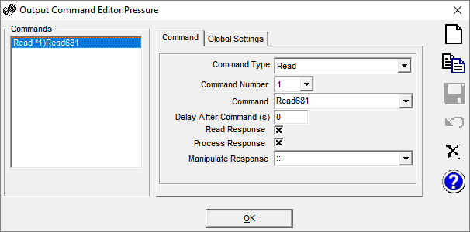

Macros: Create new GetCommand macros.

In this macro, the string construct consist of the device address - “001”, a Read or Write parameter – “R”, and the command – “MRMD”.
A universal address of “255” can be used if the 681’s address is not known.

'**************************************************
'Appends a NULL character ("0") to the end
'of the command string.

'The Additel requires a nonstandard terminating character instead
'of the traditional <CR>,<LF> options.

'This macro is called in lieu of the normal READ command string.
'**************************************************
Function Read681(Target, ChnlSt, SetMode, ParamID, cDevice)

Read681 = "001:R:MRMD" & Chr(0)

End Function

