**Swagelok ½ inch VCR fittings for molstic system and/or molbloc elements**

**Find all of these at** [**www.swagelok.com**](http://www.swagelok.com)

½ in. VCR rotating female union

1/2 in. VCR non-rotating female union

½ in. VCR male union

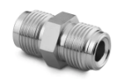

½ in.VCR to ½ inch tube fitting adapter

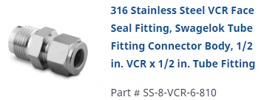

½ in. VCR female to ¼ in. VCR female union adapter

½ in. VCR male to ¼ in. VCR female union adapter

Get some metal gaskets if you want to connect at greater than 100 psi. (can’t use Viton o-rings past about 100 psi).

½ in. VCR metal gasket without retainer clips

9. O-rings from Fluke Calibration

Fluke PN 3071138, KIT, O-RINGS, ½ in. VCR, QTY=50