a3001 FC Wireless iflex Extended User Manual

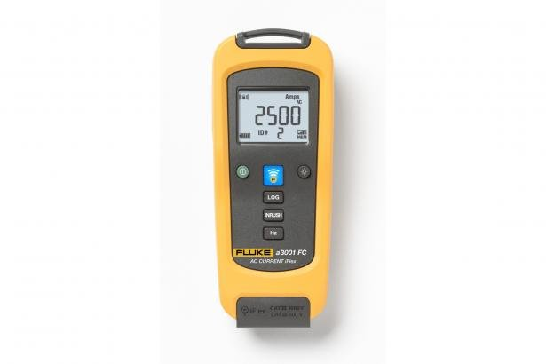

Turning the a3000FC on with the Green Button. The a3001 FC will turn off automatically in 20min. Auto power off is disabled while logging.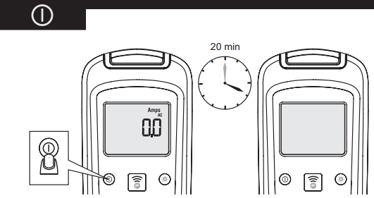

Pressing the backlight button will illuminate the backlight. 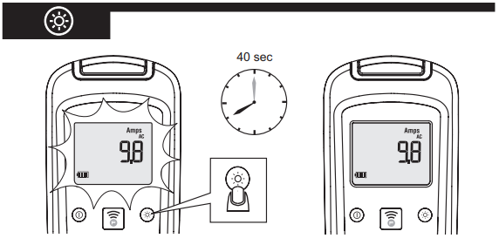

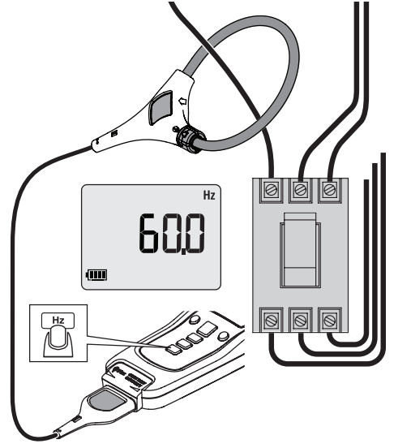Press the Hz button to toggle between frequency and amperage measurements.

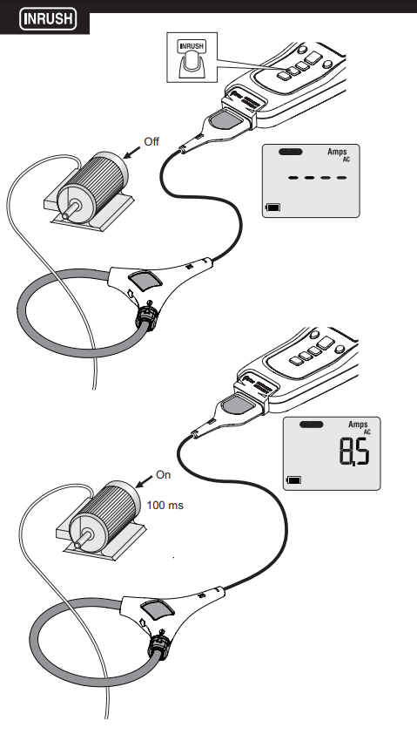

Press the INRUSH button to capture motor inrush measurements. Connect your a3001 FC to your motor and press the INRUSH button. The display will read “----” and any signal greater than 100 ms will now be captured and displayed.

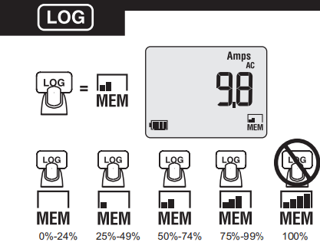

Press the LOG button to start logging. The MEM icon will appear in the lower right part of the display and will blink. The status bar located above MEM indicates available memory used (65,000 data points). No logging available with memory at 100%. The default logging interval is 15 min.

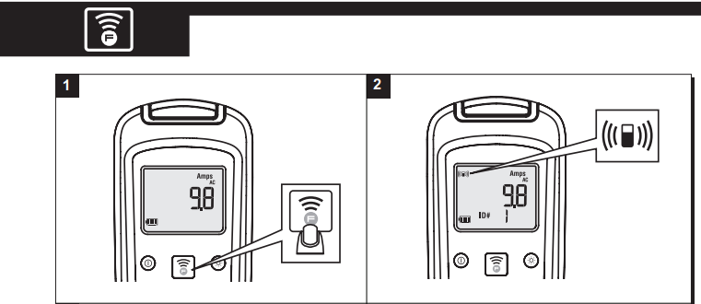

Press the Fluke Connect button to activate the wireless communication. The radio activation icon will appear on the upper left part of the display.

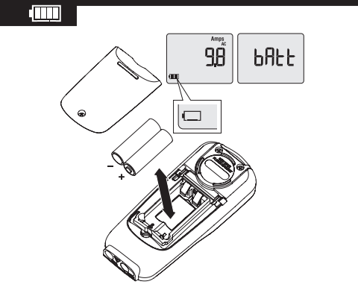

Battery charge indicator is in the lower left of the display.

Wireless Communication

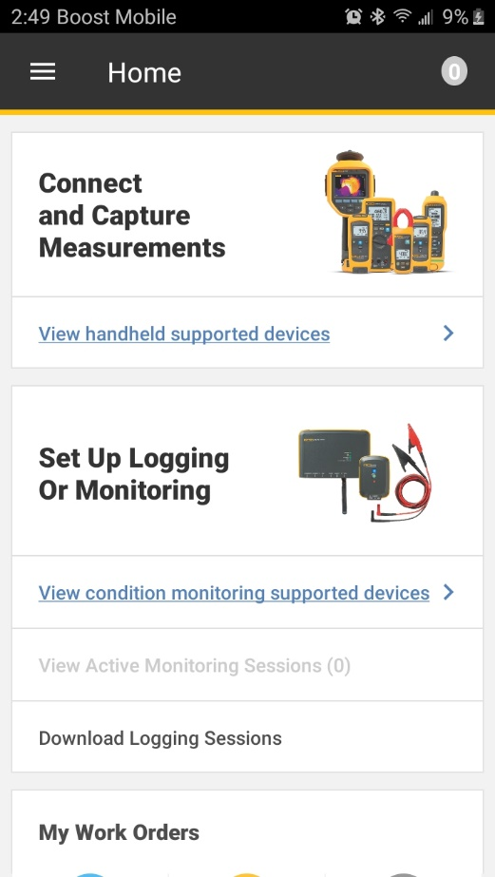Fluke Connect button allows wireless communication via Fluke Connect application ([IOS](https://apps.apple.com/us/app/fluke-connect/id694449312), [Android](https://play.google.com/store/apps/details?id=com.fluke.deviceApp&hl=en)).

From the Home screen select “Connect and Capture Measurements”.

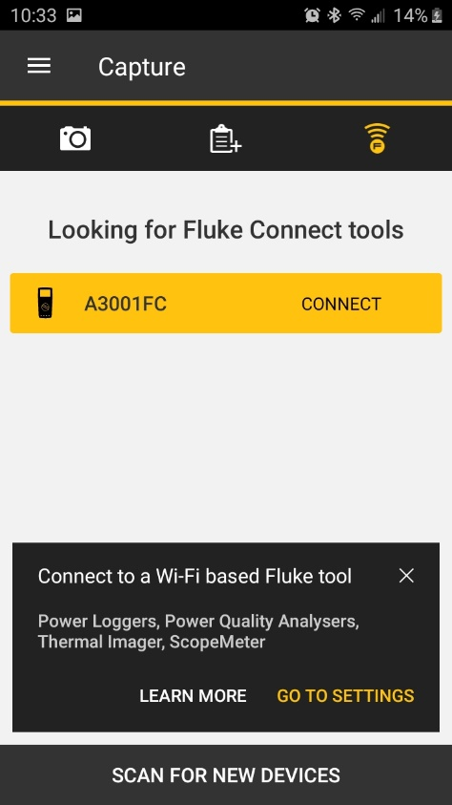

Select the device to connect.

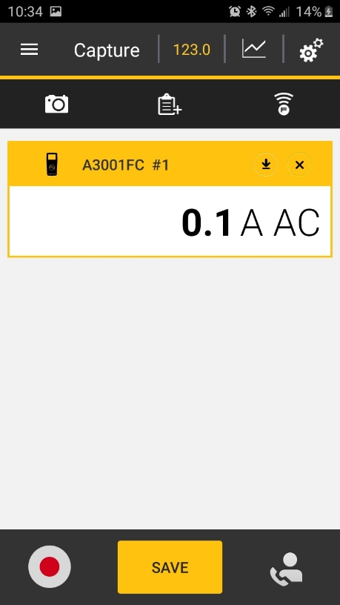

A live reading will appear on display. Individual readings may be saved from the application by selecting SAVE. Trend recordings can be saved from the application by selecting the Red record button.

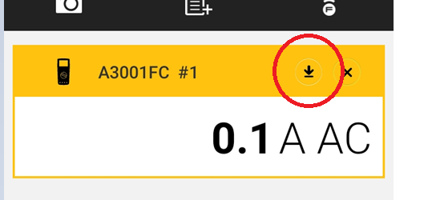

Download and Setup options can be set by pressing the Download Icon.

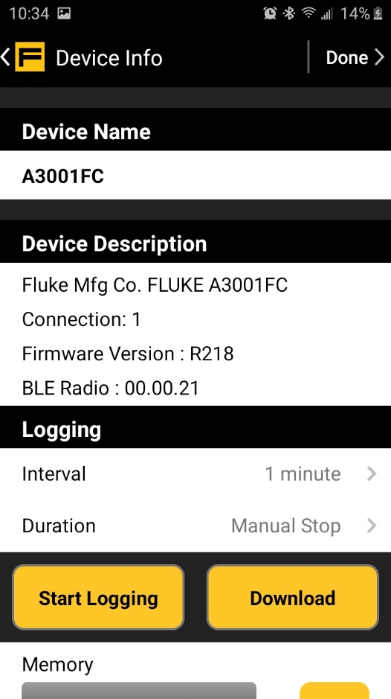

Device Name can be changed here. Device Description is displayed here (cannot be changed). Logging Interval and Duration are displayed here.

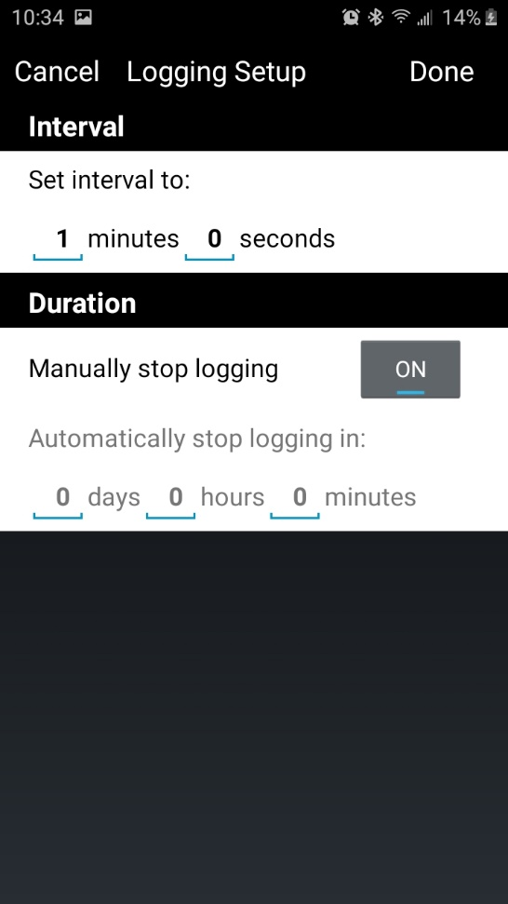

Selecting Interval or Duration allows you to modify those settings in the Logging Setup.

