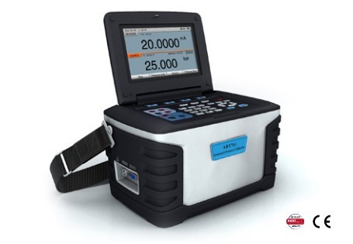
Additel 671
27 Sept 2016

- Requires a non-traditional termination character – a decimal “0”
- Must use a GetCommand macro to append “0” to end of the command string(s).
- Has a High and Low range.

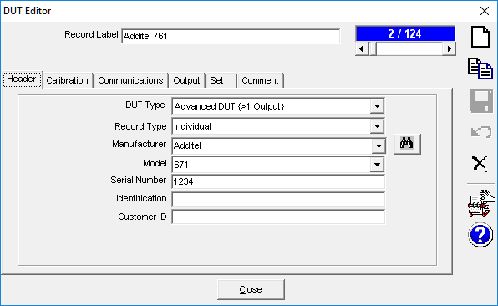

The Command and Response Terminator fields should be empty (delete):
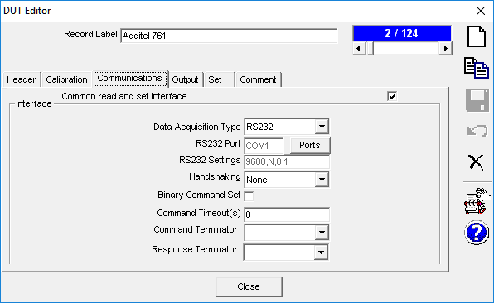

Two Outputs – both are of traditional configuration; Raw-to-Final output is <Same>. Use Tolerance of ±0.02% Span. The specifics of each output are in the Edit Commands subsection.
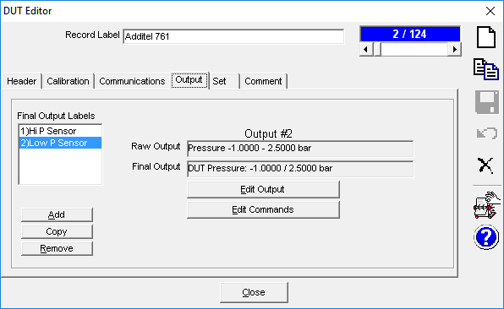

Edit Commands, “Hi P Sensor”:
Call GetCommand macro “CSwitchRange0”. Use a two second delay to allow for hardware change.
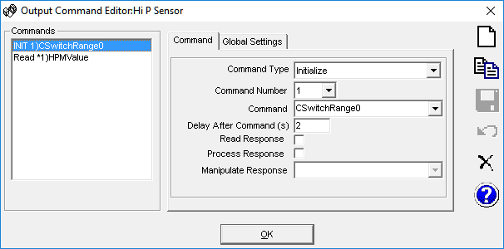

Call GetCommand macro “HPMValue”. Manipulate the response by stripping all characters up to the third appearance of a semi-colon. The 761 return string echoes the command line with the measurement appended to the end. See inset below.
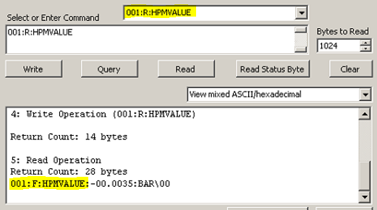
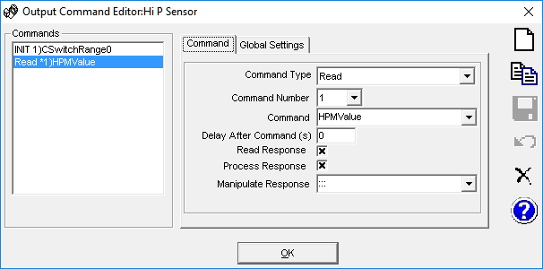

Edit Commands, “Low P Sensor”:
Call GetCommand macro “CSwitchRange1”. Use a two second delay to allow for hardware change.
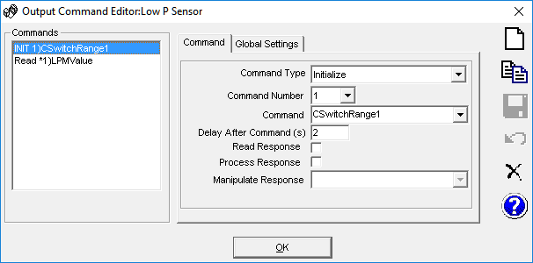

Call GetCommand macro “HPMValue”. Manipulate the response by stripping all characters up to the third appearance of a semi-colon.
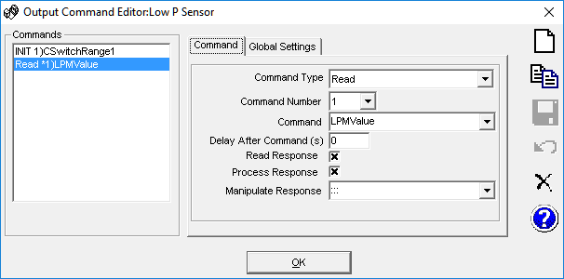

Macros: Create new GetCommand macros.

'**************************************************
'Appends a HEX NULL character ("0") to the end
'of the command string.

'The Additel requires a nonstandard terminating character instead
'of the traditional <CR>,<LF> options.

'This macro is called in lieu of the normal INITIALIZE command string.
'**************************************************
Function CSwitchRange0(Target, ChnlSt, SetMode, ParamID, cDevice)

CSwitchRange0 = "001:W:CSWITCHRANGE:0" & Chr(0)

End Function

'**************************************************
'Appends a HEX NULL character ("0") to the end
'of the command string.

'The Additel requires a nonstandard terminating character instead
'of the traditional <CR>,<LF> options.

'This macro is called in lieu of the normal INITIALIZE command string.
'**************************************************
Function CSwitchRange1(Target, ChnlSt, SetMode, ParamID, cDevice)

CSwitchRange1 = "001:W:CSWITCHRANGE:1" & Chr(0)

End Function

'**************************************************
'Appends a HEX NULL character ("0") to the end
'of the command string.

'The Additel requires a nonstandard terminating character instead
'of the traditional <CR>,<LF> options.

'This macro is called in lieu of the normal READ command string.
'**************************************************
Function HPMValue(Target, ChnlSt, SetMode, ParamID, cDevice)

HPMValue = "001:R:HPMVALUE" & Chr(0)

End Function

'**************************************************
'Appends a HEX NULL character ("0") to the end
'of the command string.

'The Additel requires a nonstandard terminating character instead
'of the traditional <CR>,<LF> options.

'This macro is called in lieu of the normal READ command string.
'**************************************************
Function LPMValue(Target, ChnlSt, SetMode, ParamID, cDevice)

LPMValue = "001:R:LPMVALUE" & Chr(0)

End Function

