COMPASS for Pressure
Test Macro to prompt for Cal Report Number and Work Order, and save to the data file

Function CalRptNum(iT, iL, iC, iP, cTest, cConfig)
For n=1 To cconfig.DUTPrs.Count

model=cconfig.DUTPrs(n).RangeMain.GetParent.Model
sn=cconfig.DUTPrs(n).RangeMain.GetParent.SN

cconfig.DUTPrs(n).RangeMain.GetParent.CalInfo3 = inputbox("Enter Calibration Report Number that you want to use for DUT # " &n & ". If none press [OK]")
CalRptNum = cConfig.DUTPrs(n).RangeMain.GetParent.CalInfo3

' Uncomment below lines if you want to prompt for work order number also. Or change text to some other needed information
' cconfig.DUTPrs(n).RangeMain.GetParent.CalInfo4 = inputbox("Enter WO Number for DUT # " & n & ". If none press [OK]")
' WrkOrdr = cConfig.DUTPrs(n).RangeMain.GetParent.calinfo4

cDebug.LogStatus "DUT # " & n & ", Cal Report Number " & CalRptNum
' cDebug.LogStatus "Work Order " & WrkOrdr
Next
End Function
Add to test as a Pre Test Macro
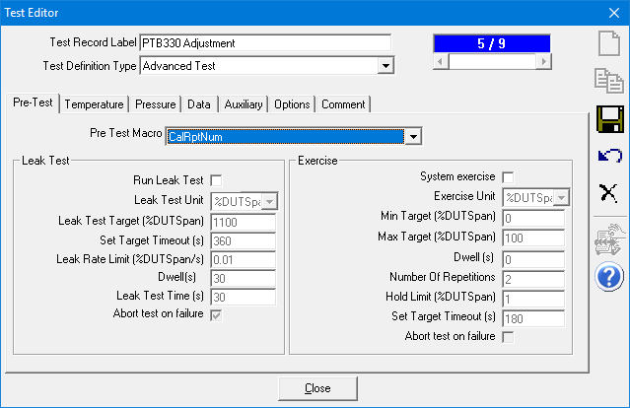

The View in COMPASS Report Editor
