Flow Training Class Station 4 COMPASS for Flow Setup
DUT Setup – 5 lpm air rotameter, calibrate in nitrogen. Setup as Simple Device

This is a Cole Parmer 5 lpm air variable area flow meter (rotameter). The scale is marked from 0.4 to 5 LPM AIR and has no other markings on it that indicate that the flow is at a specified temperature or pressure – so the flow units are as indicated and are volumetric flow units of liters per minute. In COMPASS for Flow true volumetric flow units are designated with an a in front of them for actual flow units. LPM in COMPASS is alm.
If the rotameter showed slpm, or perhaps showed lpm at 70F and 14.7 psi, then its scale would almost certainly read in mass flow units. Because rotameters are inherently volumetric flow devices the manufacturer can convert the true volumetric reading to a mass flow reading by designating the pressure and temperature (density) that the volumetrically based flow unit is at.
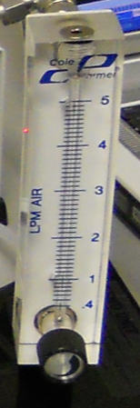

Must enter at least one; SN, ID or Customer ID
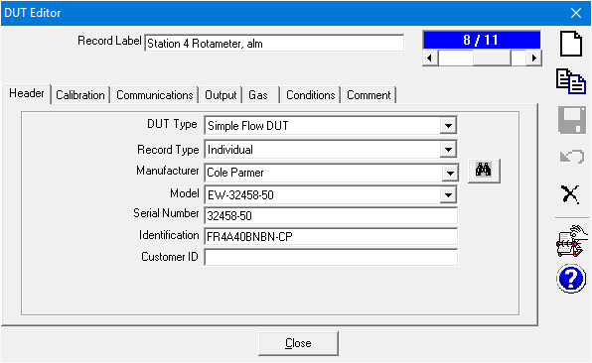
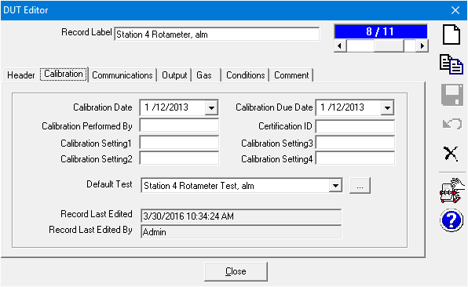
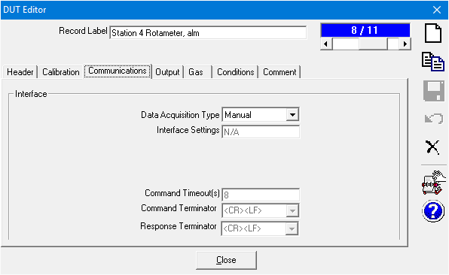
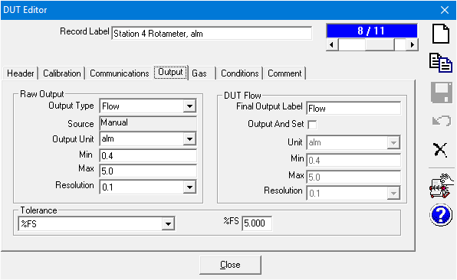
Would choose slm@70F if the scale was in volumetrically based mass flow units
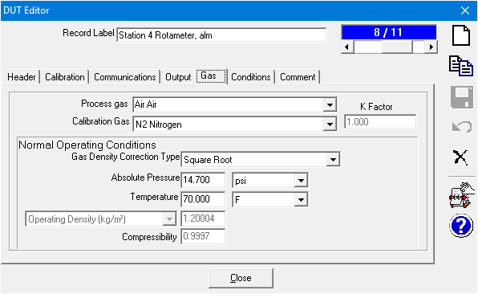
We are running the rotameter in nitrogen
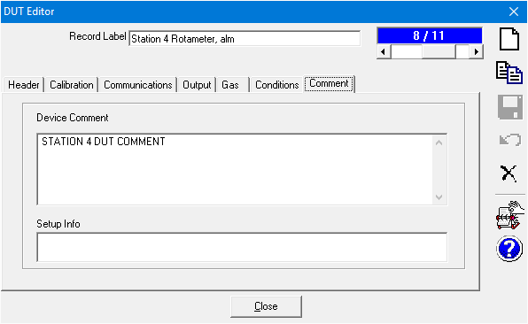

Flow Training Class Station 4 COMPASS for Flow Setup
Pressure monitor, RPM4
“Autodetect” – COMPASS will read device information, etc. Alternately you could choose a manual entry pressure and temperature device during test initialization (for volumetric flow conversion of the molbox/molbloc mass flow rate).
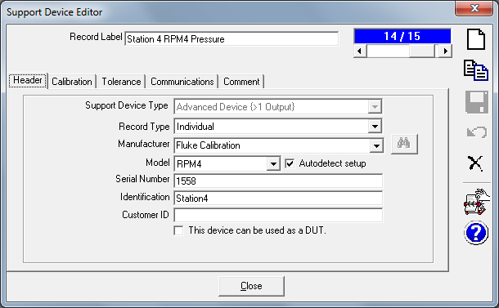
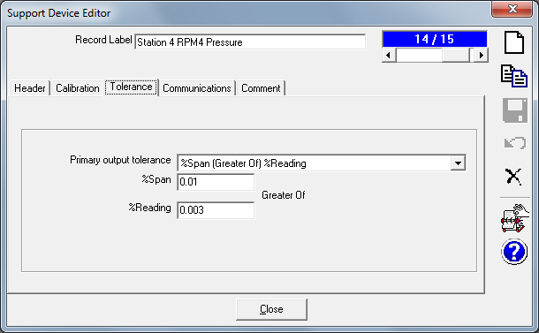
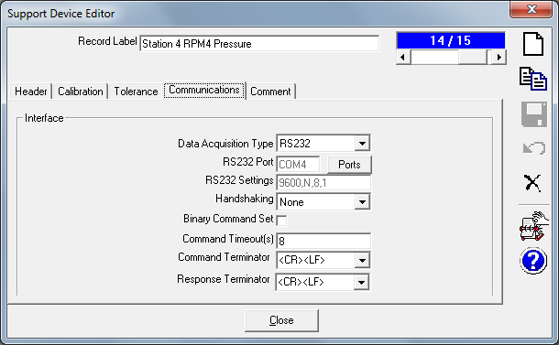
Flow Training Class Station 4 COMPASS for Flow Setup
Temperature monitor, 1524
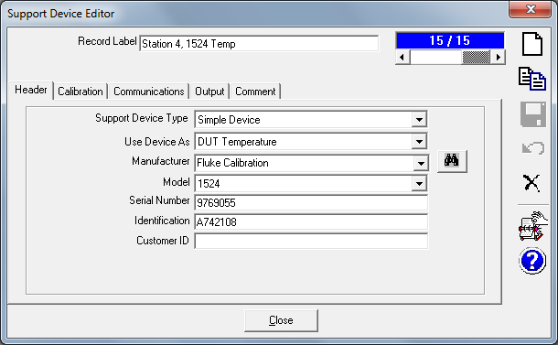
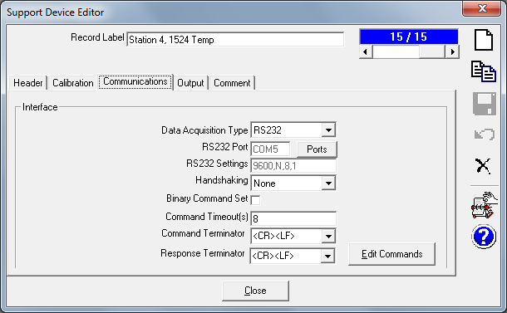
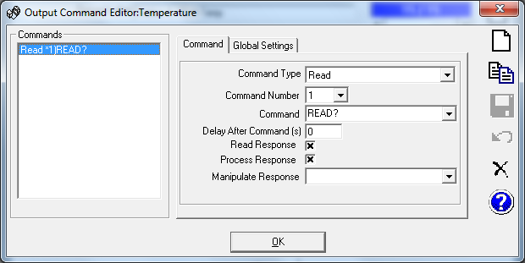
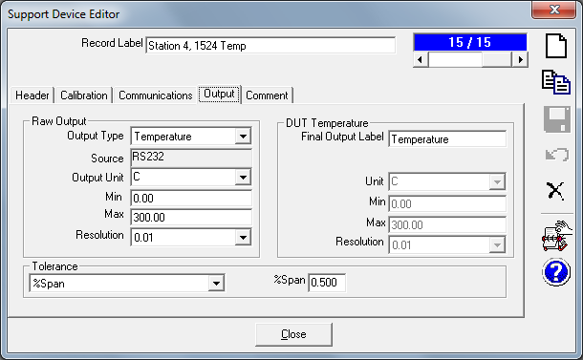
Flow Training Class Station 4 COMPASS for Flow Setup
Test Setup for 5 alm rotameter
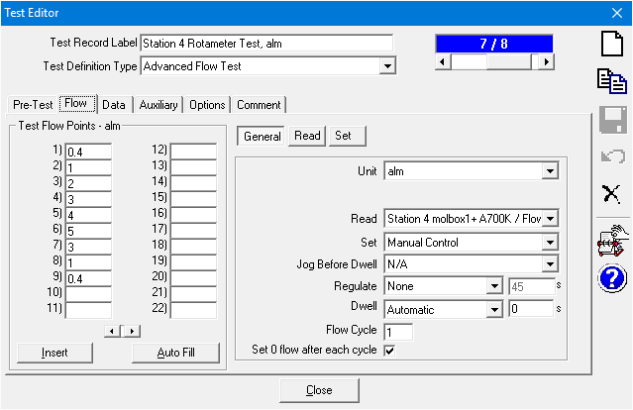

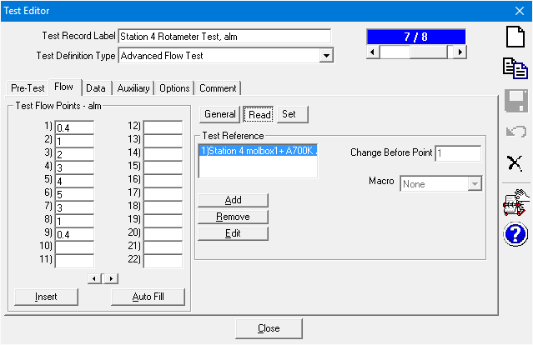
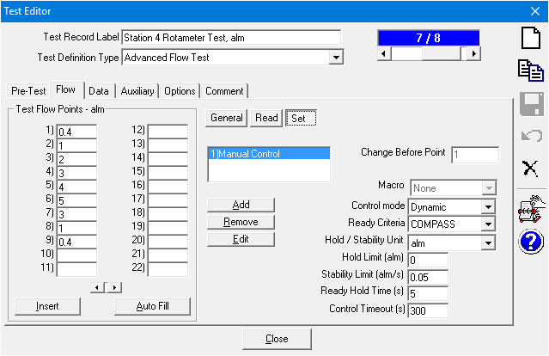

If averaging time is zero an instantaneous reading is taken.
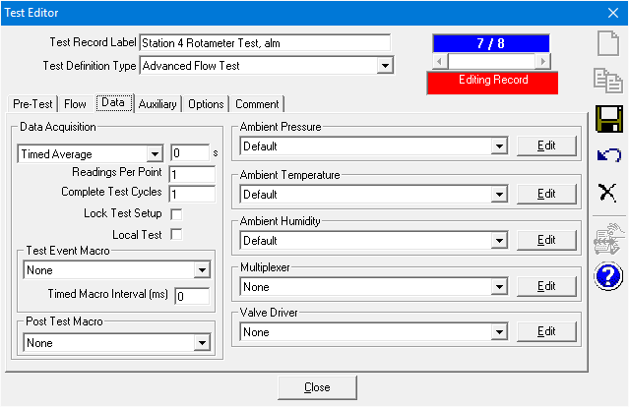
Because the DUT has a square-root density correction (part of DUT setup) COMPASS will require DUT pressure and DUT temperature. Actual devices are specified during Test Initialization not in DUT setup or test setup. No auxiliary devices.
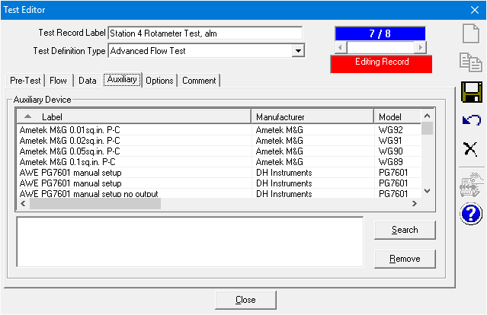
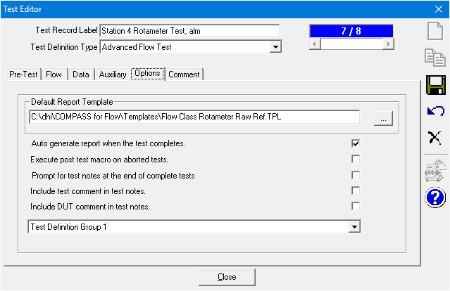
Can put Test Comments in the Test setups that can be saved in data files and printed on reports. Setup info and Picture can be shown during test initialization.
