Fluke 729 Automatic Pressure Calibrator
26 March 2020
05 May 2020 – revised. Added mA current loop support.

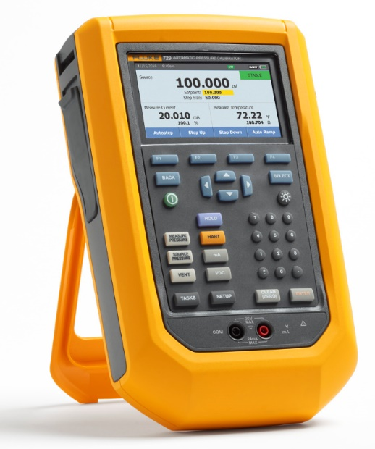
The model 729 is a portable pressure calibrator with internal pressure generation. It supports 4-20 mA current loop calibration of pressure transmitters, switches and it supports the use of external 750P pressure modules.

This tutorial shows how to configure the 729 as a Support Device for use with COMPASS for Pressure software. Key features of the setup:
- Using the internal sensor
- Using an external pressure module
- Pressure control configuration
- Vent and Zeroing support
- Using the 729 to supply the excitation voltage and to read the mA output of a DUT

Table of Contents:
- Remote Communications
- Support Device Definition overview
- Outputs
  - Output #1 – 750P Module
  - Output #2 – Internal Sensor
  - Output #3 – mA measure
- Set (Pressure Control)
- Configuring a 4-20 mA DUT and starting a test

- Remote Communications:
The 729 connects to the host computer using a USB-to-mini USB cable. When using Windows 10 the connection is auto-detected and creates a virtual COM port. Use the Windows Device Manager to view the “Ports (COM & LPT)” menu to see which port number is assigned. For this tutorial the example COM Port assignment is “6”.

9600,N,8,1 = The 729’s COM port settings are hard coded for a baud rate of 9600, with parity of None, eight data bits, and one stop bit.

- Support Device Definition:
The 729 is configured as a Support Device so that it can be used as both a calibration standard and as a DUT. The images show it is configured as a Profile for the Record Type – this is optional. For most users, it’s expected that they will have only one of these units and therefore it would make sense to change the Record Type to “Individual”. If so then a Serial Number entry will be required on this screen.

The Calibration and Comment tabs are optional. Information does not need to be provided for these tabs to have a valid Support Device Definition.

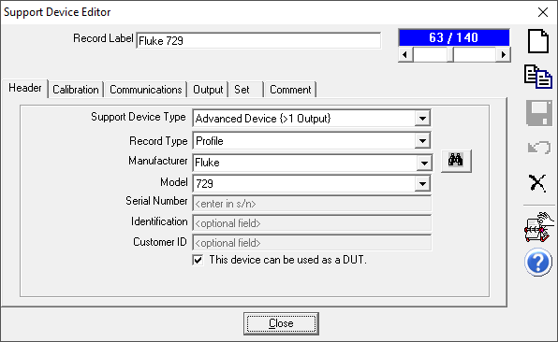
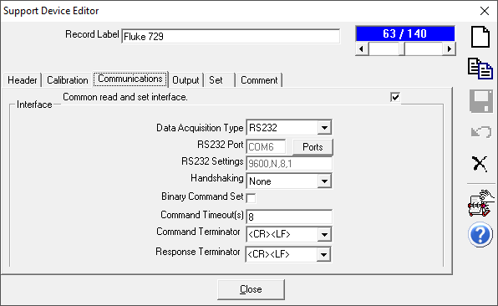
- Outputs:
The 729 is configured with two outputs. Each output can be thought of as a separate range or measurement function within the instrument. Each output has its own remote commands and tolerance details. The specifics of each output will vary for each operator based on the exact model and if external 750P pressure modules are used. If it’s desired to use multiple 750P modules then a separate Output can be created for each module.
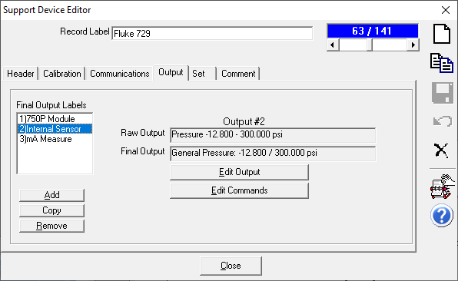

  - Output #1: Use the Add button to create a new Output for the 750P module:
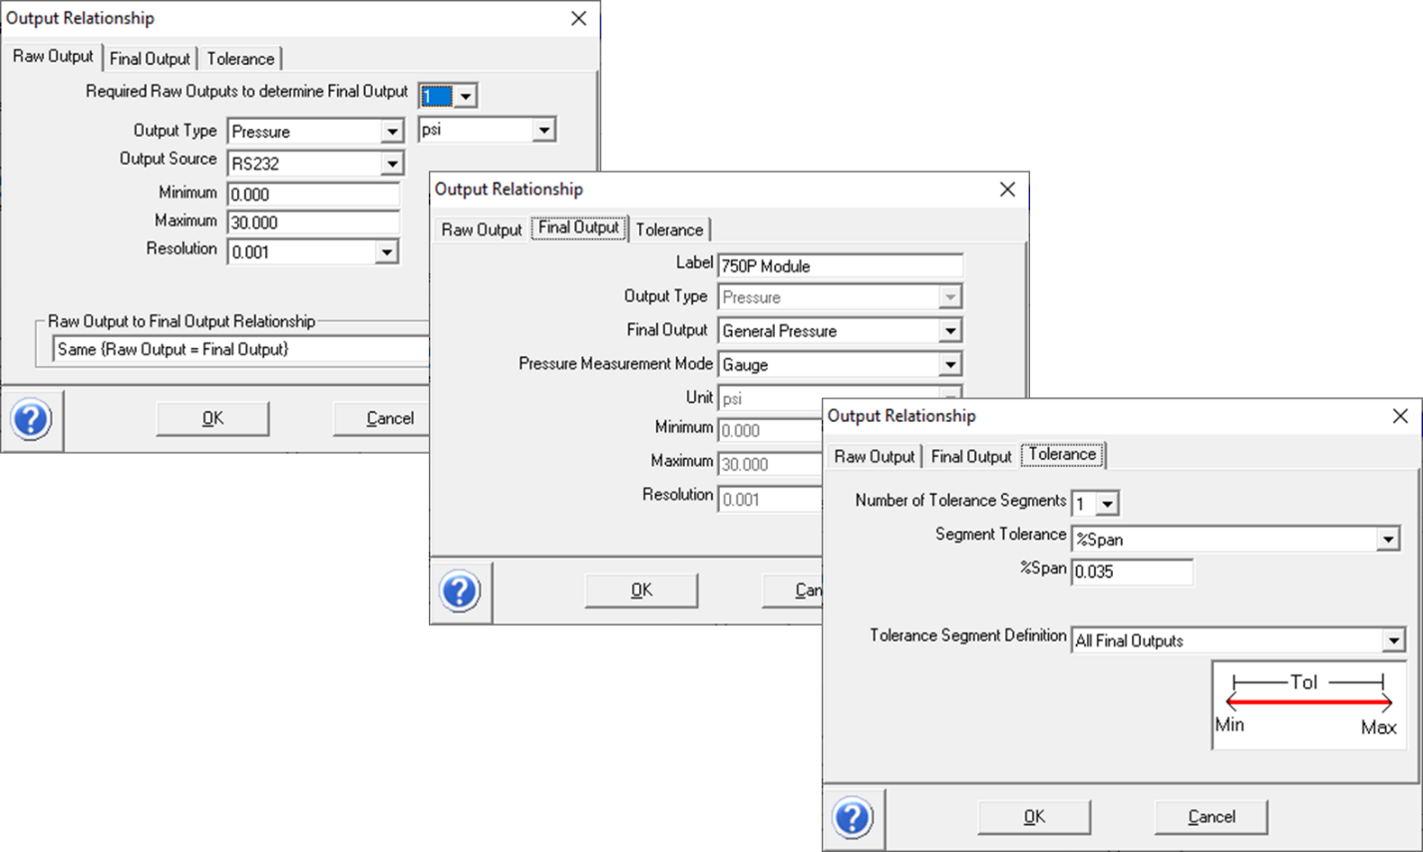
Use the Edit Commands button to add in the remote commands. With this example, there is a series of six Initialization commands which are used to place the 729 in a known mode of operation. This is includes a sequence for venting the unit and then zeroing out the sensor. Click the “new” icon to create a new remote command entry. Click the “save” icon when finished for each command. There are no selections to be made on the Global Settings tab.

Except for the VENT command all Initialization commands are configured with the same selections as shown for the EHCO command:

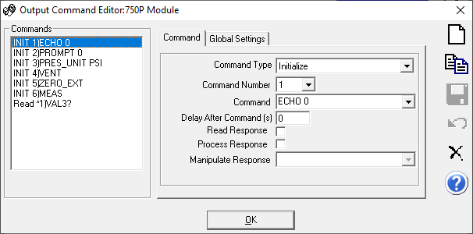

The VENT command uses a 5 second delay to allow for the venting process to complete prior to zeroing:
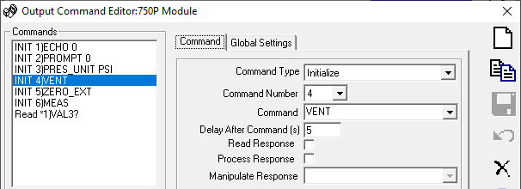

The last command is a Read type. It is important to enable the Read Response and Process Response options. When finished, save the command and click the okay button. Then save the Support Device definition.
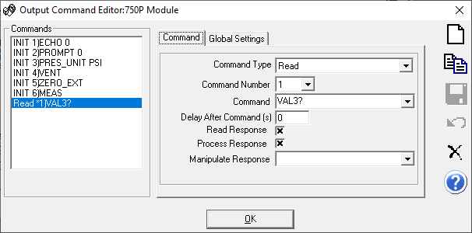

  - Output #2: Use the Add button to create a new Output for the internal pressure sensor:
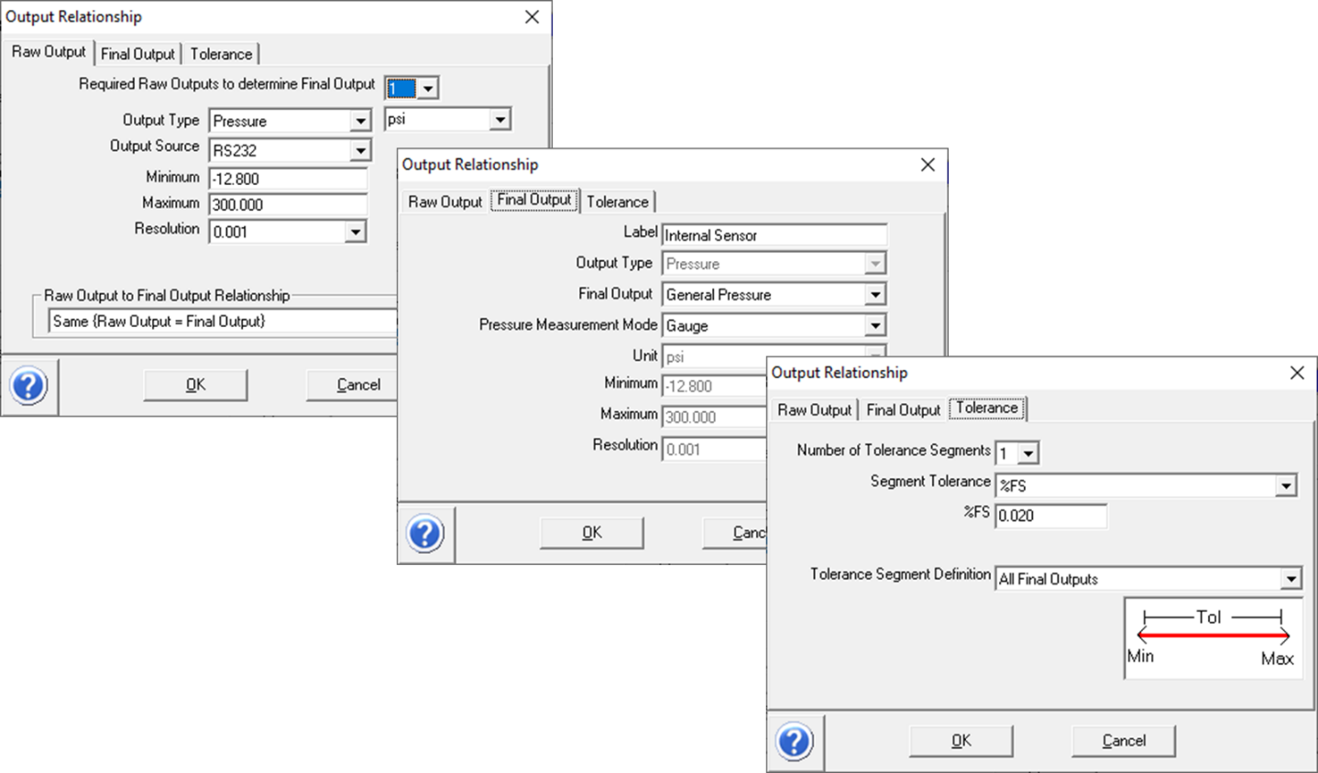

Use the Edit Commands button to add in the remote commands. The commands are similar to the 750P output with the only difference being the ZERO command. Use the same method adding a new one and saving for each command entry.

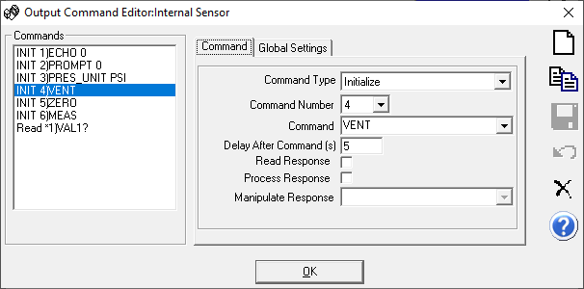
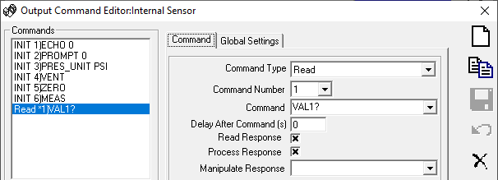

- Output #3: Use the Add button to create a new Output for the current loop (mA) support:
This output would be required for the calibration of pressure transmitters. The calibration scheme is to use the 729 as both the source for the excitation power and to measure the Raw Output from the DUT.
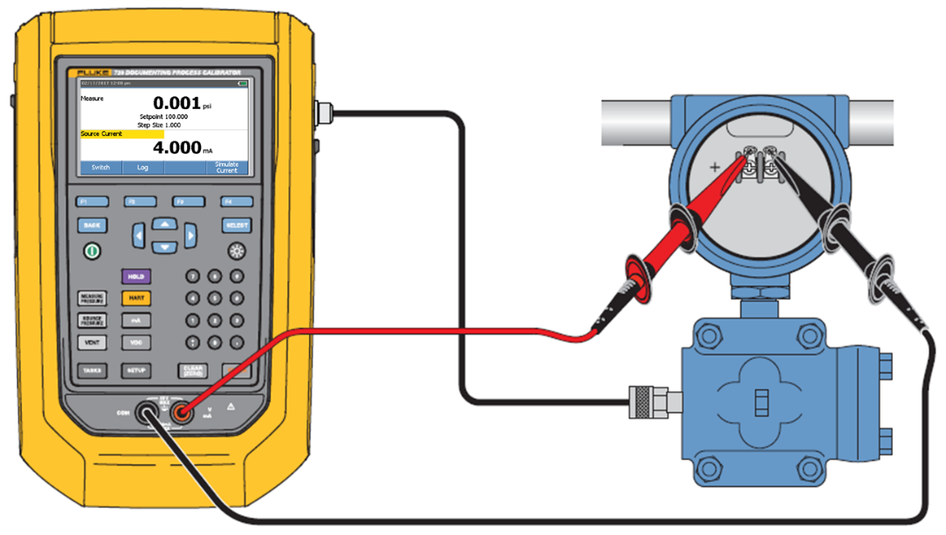

The Raw Output tab of the 729 is defining the capability of the 729 and not that of the DUT. This is why it’s listed as a generic 0 to 24 mA.
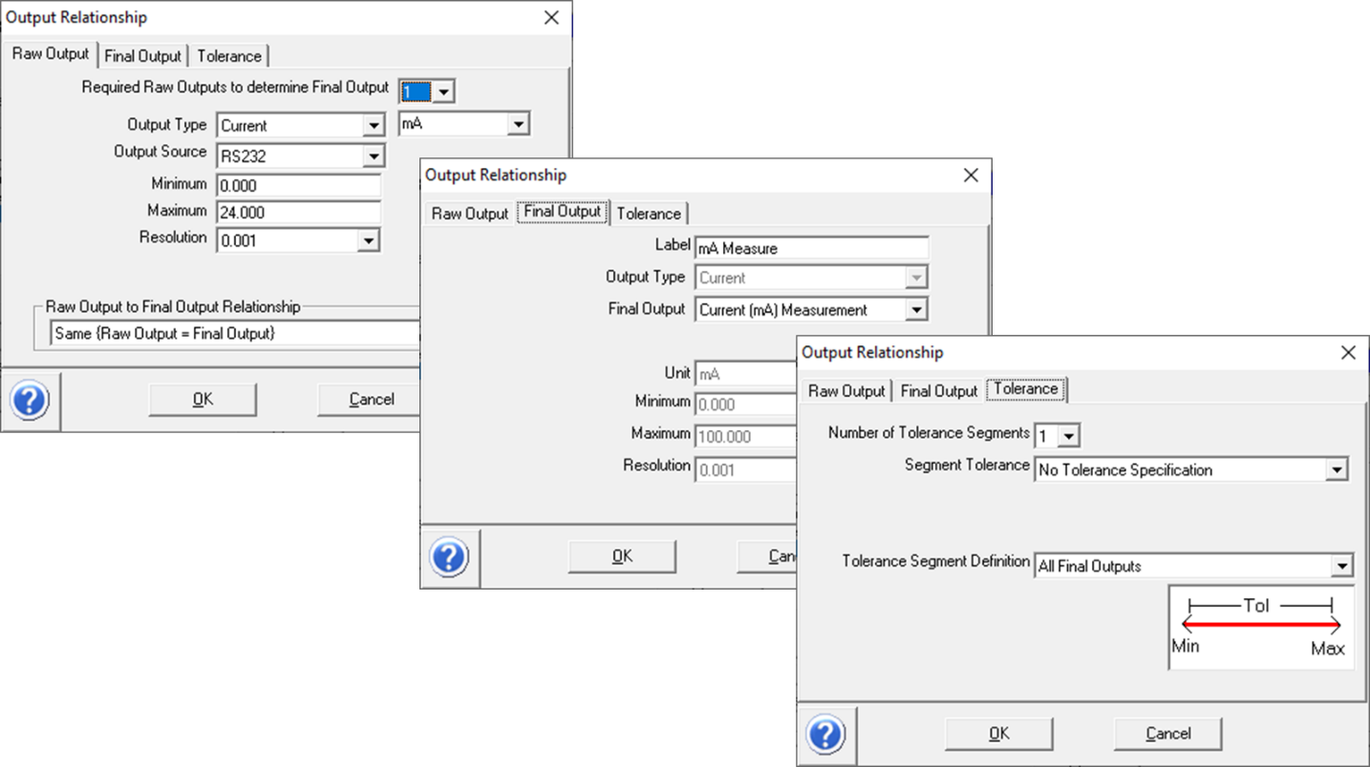

The remote commands:
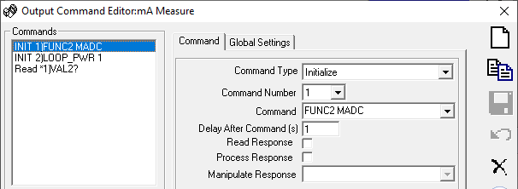
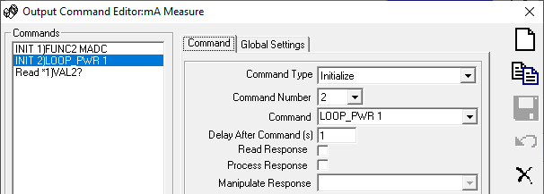
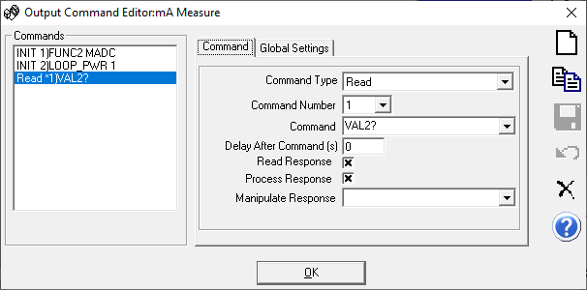

When a test has completed, it may be desired to turn off the loop power. This can be accomplished via the front panel - power OFF, or press the VDC key to get out of loop power mode. For more advanced automation, a post-test macro could be used to send a remote command to turn off the loop power.

Post Test macros are called on the Data tab of the Test Definition:
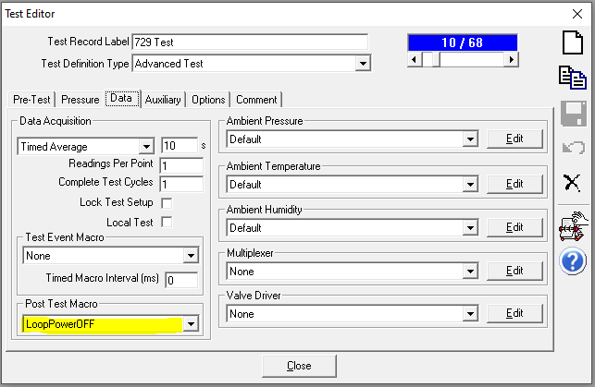

VB Script code for the macro:
'**************************************************
'Called as a Post-Test macro to turn off the 24VDC loop
'power of the Fluke 729
'
'**************************************************
Function LoopPowerOFF(iT, iL, iC, iP, cTest, cConfig)

LoopPowerOFF = cConfig.RefPrs(1).IoSendCommand ("LOOP_PWR 0",True)
TimeDelay 1
End Function

- Set (Pressure Control):
The Set tab is where the pressure control operations are defined. There is a single command used to set the pressure on the 729 and it is shared with the three Outputs. There are configurations used for venting and aborting operations.

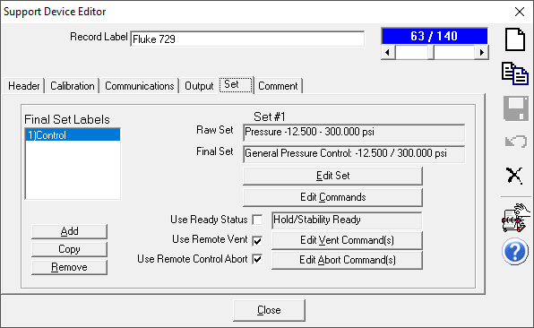

Final Set Label: Use the Add button to create a new Set Relationship. This defines the capability of the 729 as a pressure controller and it is independent of which pressure output is being used. Match the Maximum pressure value to the particular configuration of the 729. In this example it has a 300 psi full scale internal pressure sensor. Other models could be configured for a lower pressure range.

The 729 has capability for vacuum control down to approximately 2 psi above absolute zero. In this example barometric pressure is approximately 14.5 psia which places the lower threshold around -12.5 psig. The lower end of the 729 will vary based on the elevation of where it’s being used (for example, being used in Denver, CO vs San Diego, CA). There is no tolerance specification associated with pressure control.
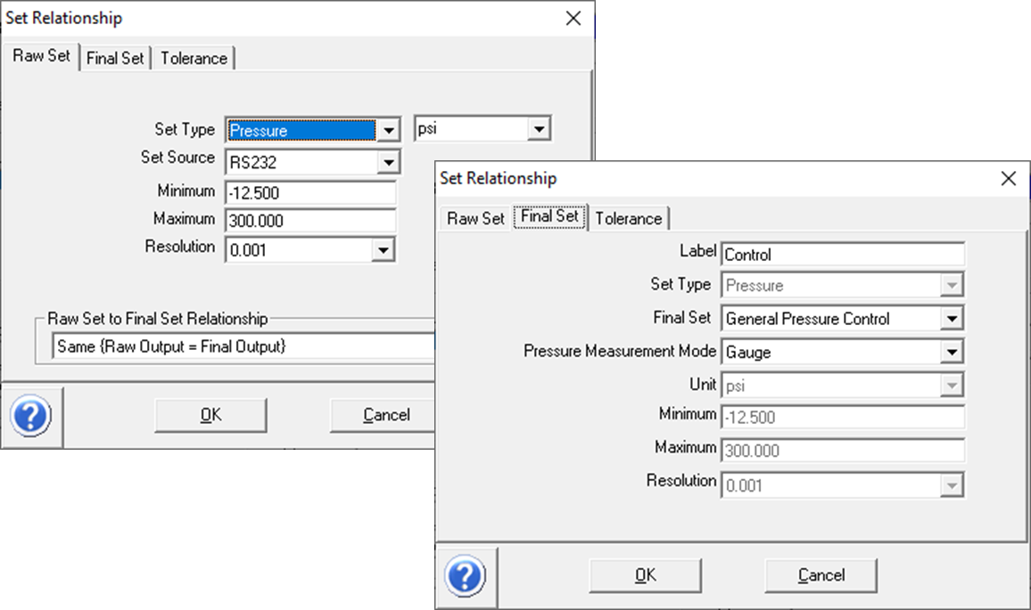

Use the Edit Commands button to add in the remote commands. The remote command for setting a pressure is “OUT x” where x is the desired pressure value. COMPASS uses a scheme of substituting in the target pressure into the “[x]” block. The target pressure comes from the Test Definition being used in a calibration, and the value is updated for each test point. There are no Global Settings selections to be made.

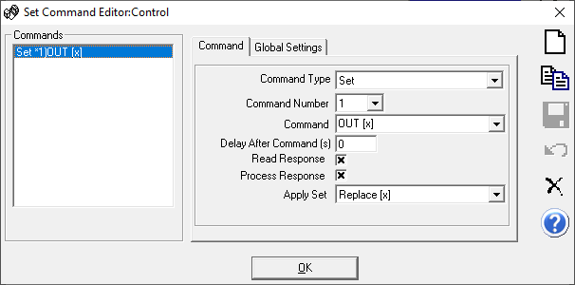

The COMPASS program provides options to vent the pressure at the conclusion of a test, and it has options for what to do with the pressure when a test is aborted in mid-flow. Theses features are configured under the Use Remote Vent and Use Remote Abort options. Both options use the same pair of commands.

Edit Vent Command(s) and Edit Abort Command(s):
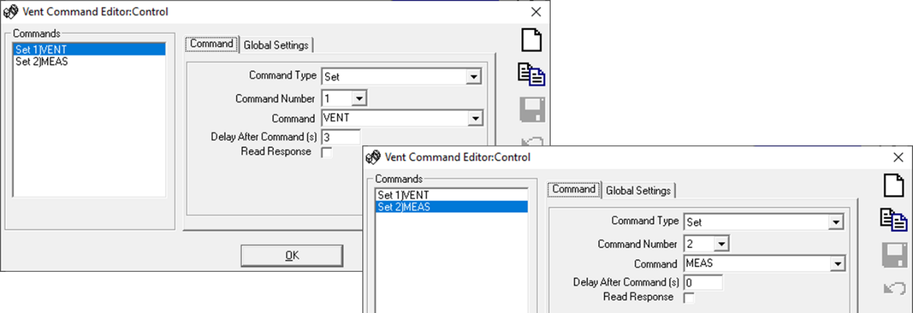

The Comment tab can be used to provide notes to assist the operator.
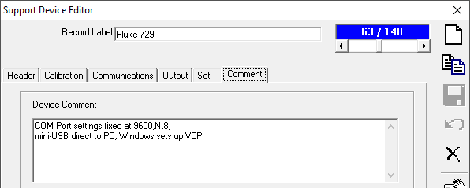

- Creating a 4-20 mA DUT
The 729 supports current loop devices by providing a 24 volt loop power and measuring the current (mA) output of a pressure transmitter. When configuring a DUT definition in COMPASS the user is required to define the DUT output in terms of the Raw and Final outputs. A pressure transmitter is a great example where the Raw is different from the Final. The Raw output is in units of mA and the Final output is in pressure units (such as psi). Here is an example of a simple Transmitter with linear scaling between the Raw and Final outputs.

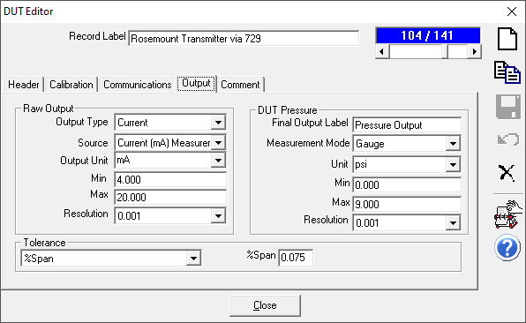

When initializing a test where the DUT has an analog Raw output COMPASS recognizes that a secondary device is required to measure and digitize the mA signal. The key selection is for the operator to use the drop-down menu to select the device which will measure the “Current (mA)”. In this example the “Fluke 729 / mA Measurement” is being used.
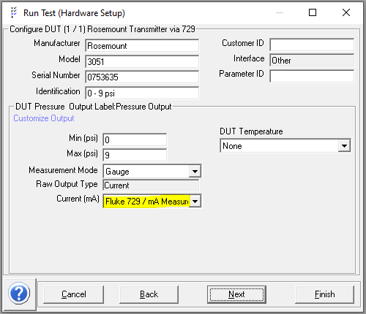

(end of tutorial)

